Set 25: Website Traffic Analysis

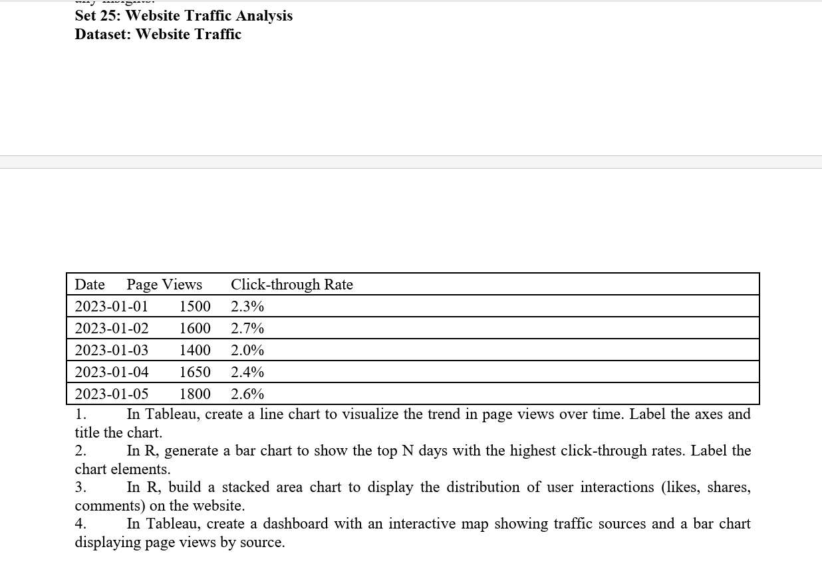

1. Line Chart – Page Views Over Time
Aim: To create a line chart in R to visualize the trend in website page views over time.
R code:

# Create dataset
date <- c("2023-01-01", "2023-01-02", "2023-01-03",
"2023-01-04", "2023-01-05")
page_views <- c(1500, 1600, 1400, 1650, 1800)

# Create data frame
data <- data.frame(date, page_views)

# Draw line chart
plot(data$page_views, type = "o",
xaxt = "n",
xlab = "Date",
ylab = "Page Views",
main = "Website Page Views Over Time",
col = "blue", lwd = 2)

axis(1, at = 1:5, labels = data$date)
Output:

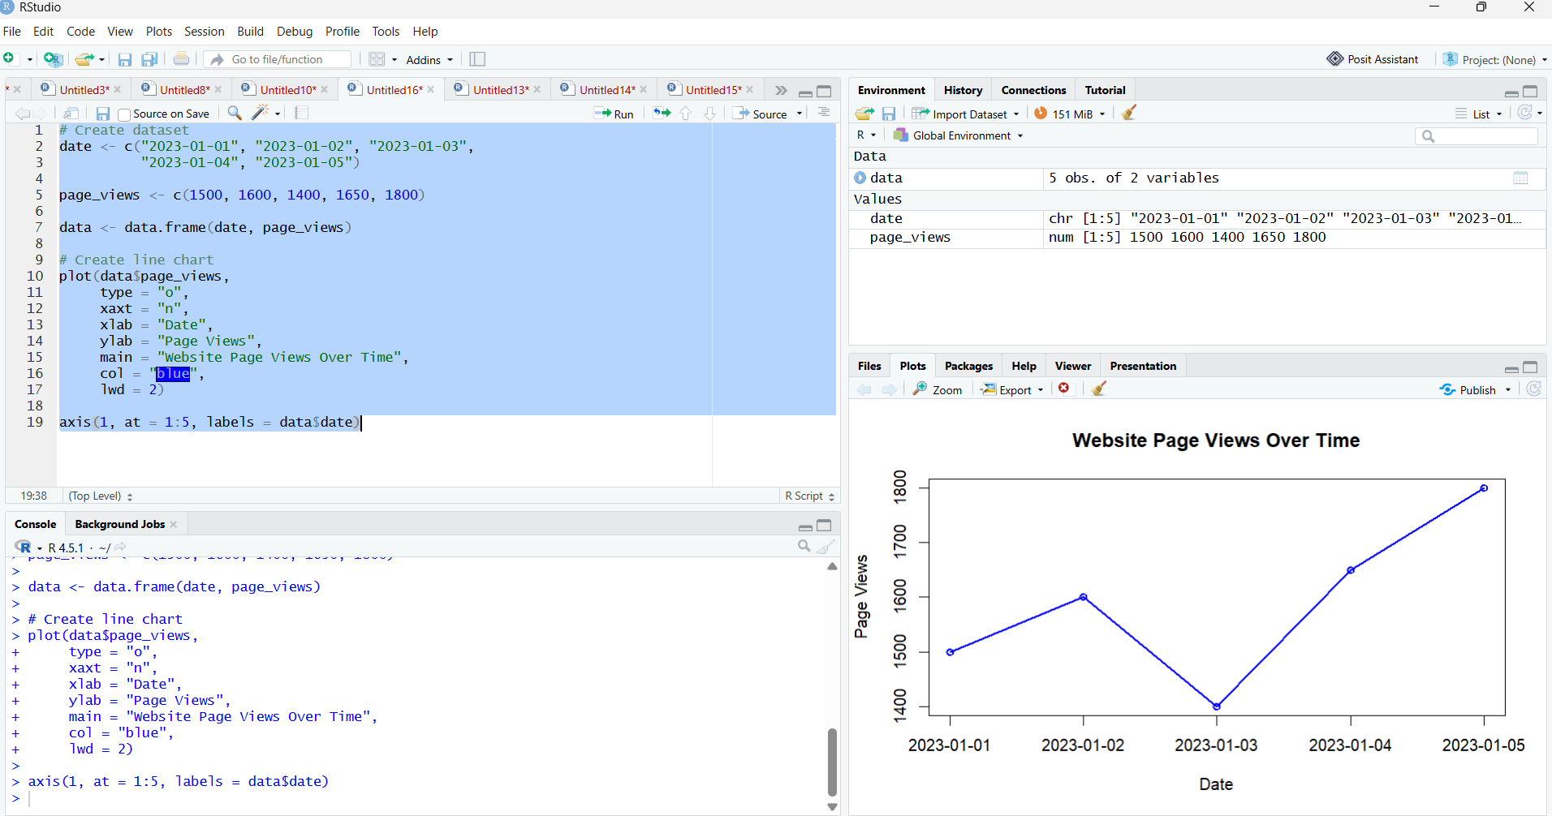

Result: The line chart displays website page views over five days. Page views increase from 1,500 to 1,800, with a temporary decrease on January 3, 2023.

2. Bar Chart – Highest Click-through Rates
Aim: To generate a bar chart in R showing the days with the highest click-through rates (CTR).
R Code:
# Create dataset
date <- c("Jan 1", "Jan 2", "Jan 3", "Jan 4", "Jan 5")
ctr <- c(2.3, 2.7, 2.0, 2.4, 2.6)

data <- data.frame(date, ctr)

# Sort data by CTR
data <- data[order(data$ctr, decreasing = TRUE), ]

# Select top 3 days
top_days <- head(data, 3)

# Draw bar chart
barplot(top_days$ctr,
names.arg = top_days$date,
col = "skyblue",
main = "Top 3 Days by Click-through Rate",
xlab = "Date",
ylab = "Click-through Rate (%)",
ylim = c(0, 3.5))
Output:

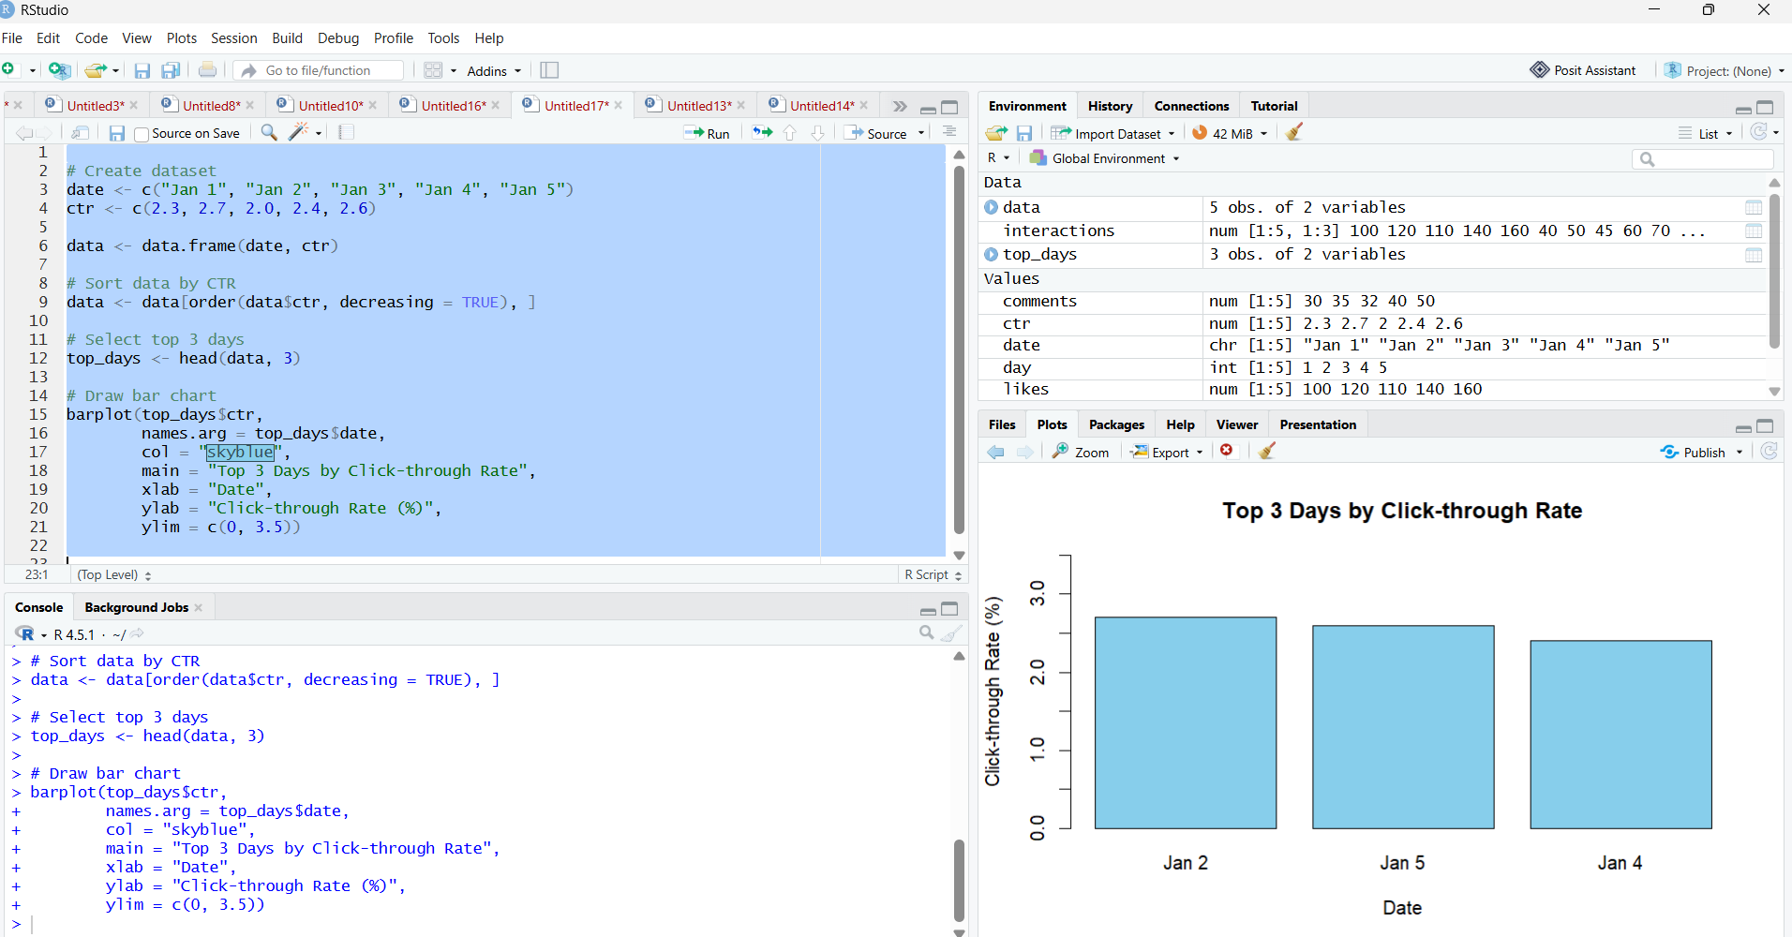

Result: The bar chart identifies the three days with the highest click-through rates: January 2 (2.7%), January 5 (2.6%), and January 4 (2.4%).

3. Stacked Area Chart – User Interactions
Aim: To create a stacked area chart in R to visualize the distribution of user interactions, including likes, shares, and comments.
R Code:
day <- 1:5
likes <- c(100, 120, 110, 140, 160)
shares <- c(40, 50, 45, 60, 70)
comments <- c(30, 35, 32, 40, 50)

data <- data.frame(day, likes, shares, comments)

interactions <- cbind(likes, shares, comments)

barplot(t(interactions),
names.arg = day,
col = c("skyblue", "lightgreen", "pink"),
main = "User Interactions",
xlab = "Day",
ylab = "Number of Interactions",
legend.text = c("Likes", "Shares", "Comments"))

Output:
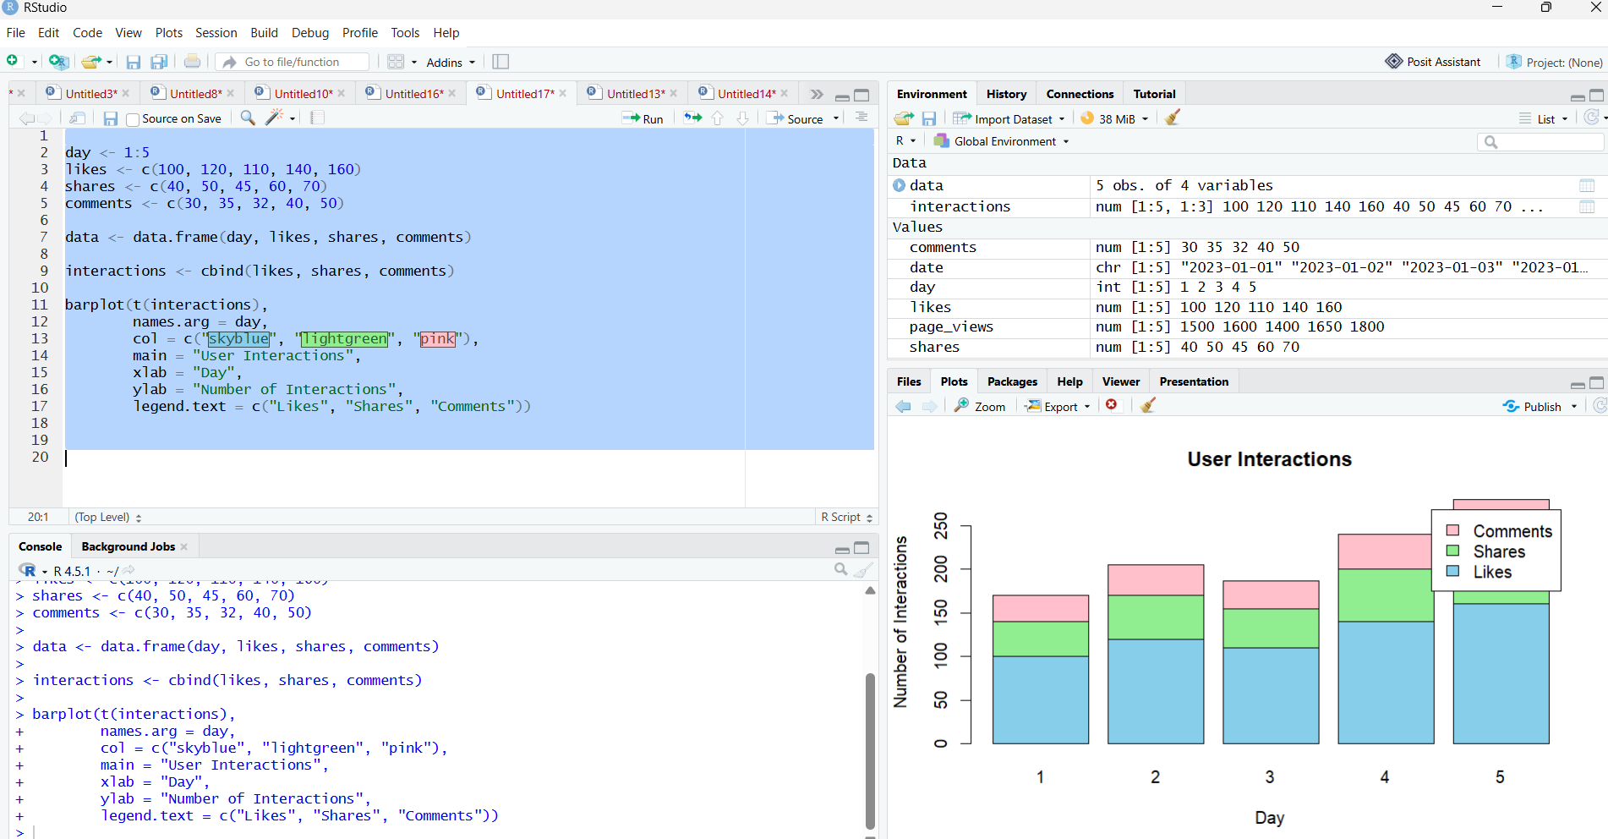

Result: The stacked area chart shows the distribution of likes, shares, and comments over five days. The sample data indicates an overall increase in user interactions.

4. Dashboard – Traffic Sources and Page Views
Aim: To create a dashboard in Tableau containing a map of traffic sources and a bar chart displaying page views by source.

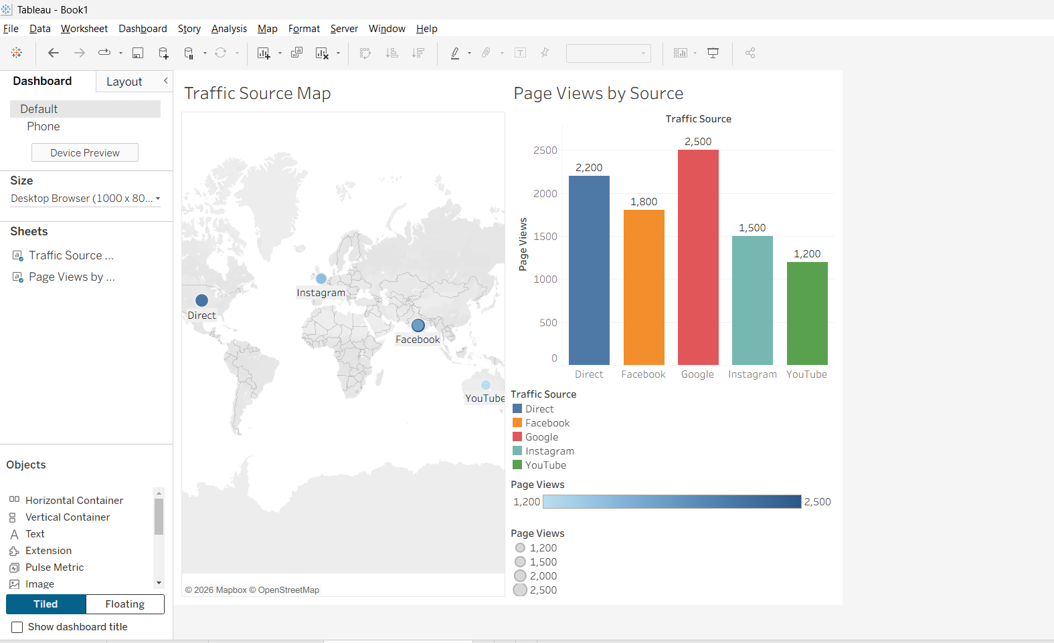

Result: The bar chart compares page views from Google, Facebook, Direct, Instagram, and YouTube. The Tableau dashboard combines the traffic-source map and bar chart to support interactive traffic analysis.

